%RAML 1.0
title: New API
mediaType:
- application/json
protocols:
- HTTP
/new-resource:
get:
responses:
"200":
body:
type: Responsedata
types:
Responsedata:
example:
strict: true
value:
WeatherReport:
predictionchannel: astro
predictionchannelcode: "2022050506"
temperatureRecords:
-
day: goodday
cloudcover: "7"
-
day: goodday
cloudcover: "7"
properties:
WeatherReport:
properties:
predictionchannel:
example: astro
type: string
predictionchannelcode:
example: "2022050506"
type: string
temperatureRecords:
items:
properties:
day:
example: goodday
type: string
cloudcover:
example: "7"
type: string
ramal code

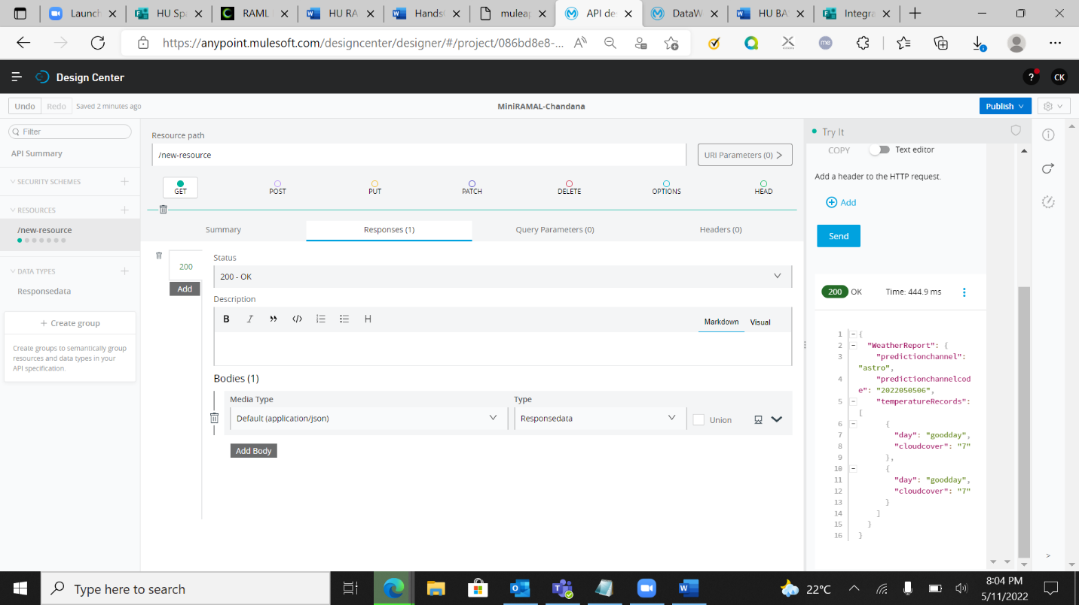
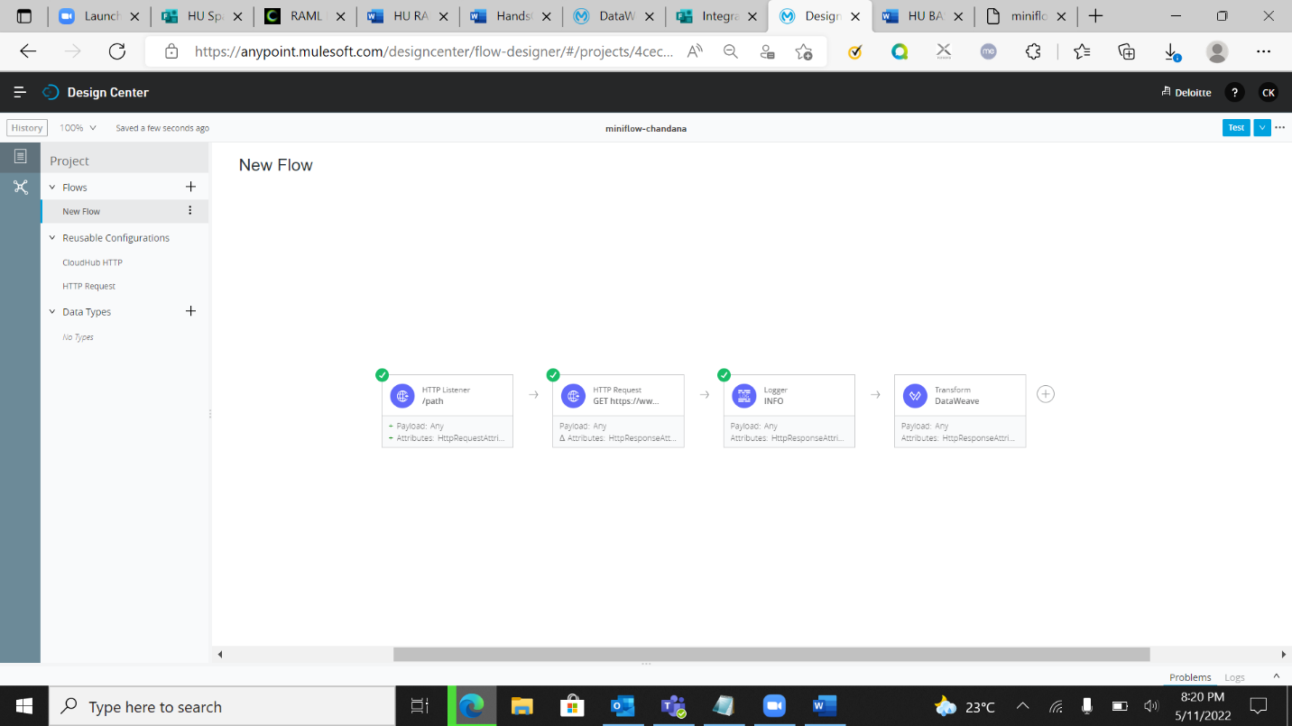

miniflow-chandana-mlrx.us-e2.cloudhub.io/path